**CBC Lifegroups List by Day**

**From March 2025**

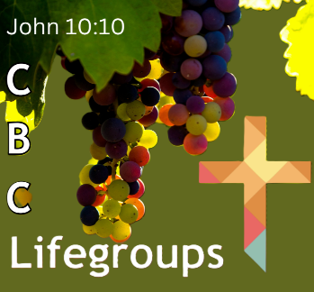**All Lifegroups are meeting in-person, some also offer Zoom**

To join a LIFEgroup, please contact: Kathryn Morgan

Email: [lifegroups@creechbc.co.uk](mailto:lifegroups@creechbc.co.uk)

Phone: 07813944575

|  |  |  |  |
| --- | --- | --- | --- |
| **Day/Time** | **LIFEgroup** | **Leaders** | **Location** |
| Monday  7.00-8.30pm | **Firepool** | Angela Coakes, Colin Figures  (Host Diane Woosley) | Canal Court  Taunton |
| Monday  7.30pm | **Ham In-person** | Rob & Kath Felix | Ham, CSM |
| Monday  7.30pm | **18-30 Group** | Emily Franklin & Fiona Bailey | East Lyng |
| Tuesday  10.30-12.30am | **Oasis**  (Women only) | Emily Tomes  Lubna Kirby, Sue Whitmore | Various homes |
| Tuesday  7.30pm | **Canalside** | David & Shirley Pengilly | Stoborough Lodge, CSM & Nortoft, Creech Heathfield |
| Tuesday  7.30pm | **North Curry** | Ewen & Pam Huffman  Tim & Pam Walker | North Curry |
| Tuesday  7.30pm | **Puppets** | Nick & Rachel Birch | Monkton Heathfield |
| Tuesday  7.30pm | **Ryesland** | Ralph & Marjorie Bullock | Ryesland Way CSM |
| Wednesday  10.30am | **Paddock** | Gary & Viv Grief | Paddock Close, CSM |
| Wednesday  7.30pm | **Encounter** | Sharon Barnes (Hosts Jez & Sharon Barnes) | Ruishton |
| Wednesday  8.00pm | **Ham by Zoom** | Rob & Kath Felix | Zoom (Ham, CSM) |
| Wednesday  7.30pm | **Orchard** | Mark & Judy Fox | ByCanal CSM |
| Wednesday  7.30pm | **The Mill** | Suzanne Cavaghan Lynne Ellis (Admin) | Thurloxton |
| Wed / Thurs  7.30pm | **J24** | Peter & Kathryn Morgan  Brian Weightman | Wilstock & Stockmoor Villages, North Petherton |
| Thursday  7.00pm | **Gateway** | Cath McKenzie | Caray Grove, CSM |