CBC Lifegroups List by Day
From April 2026
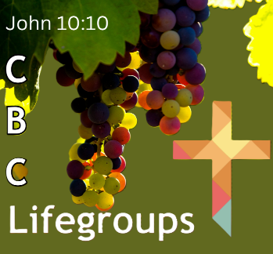
All Lifegroups are meeting in-person, some also offer Zoom

To join a LIFEgroup, please contact: Kathryn Morgan
Email: lifegroups@creechbc.co.uk
Phone: 07813944575
Day/Time | LIFEgroup | Leaders | Location
Monday  7.00-8.30pm | Firepool | Pete Green, Colin Figures  (Host Diane Woosley) | Canal Court  Taunton
Monday  7.30pm | Ham In-person | Rob & Kath Felix | Ham, CSM
Tuesday  10.30-12.30am | Oasis  (Women only) | Emily Tomes  Lubna Kirby, Sue Whitmore | Various homes
Tuesday  10.30-12.00am | Streams  (Women only) | Nicky Le Page  (Host Sarah Dendy) | Ruishton
Tuesday  2.00pm | Wellington | Jackie Perry | Wellington
Tuesday  7.00pm | Canalside | David & Shirley Pengilly | Stoborough Lodge, CSM & Nortoft, Creech Heathfield
Tuesday  7.30pm | North Curry | Ewen & Pam Huffman  Tim & Pam Walker | North Curry
Tuesday  7.30pm | Puppets | Nick & Rachel Birch | Monkton Heathfield
Tuesday  7.30pm | Ryesland | John & Angie Thompson (Assts)  (Host Phyllis Jones) | Homefield Close, CSM
Wednesday  7.00pm | 18-30 Group | Emily Franklin & Fiona Bailey | East Lyng
Wednesday  7.30pm | Encounter | Sharon Barnes  Richard & Jane Birch | Ruishton
Wednesday  8.00pm | Ham by Zoom | Rob & Kath Felix | Zoom (Ham, CSM)
Wednesday  7.30pm | Orchard | Mark & Judy Fox  Reuben & Dawn Willcocks | ByCanal CSM
Wednesday  7.30pm | The Mill | Suzanne Cavaghan  Lynne Ellis (Admin) | Thurloxton
Wednesday  7.30pm | J24 | Peter & Kathryn Morgan | Wilstock & Stockmoor Villages, North Petherton
Thursday  10.30am | Paddock | Gary & Viv Grief | Paddock Close, CSM
Thursday  7.00pm | Gateway | Cath McKenzie | Gotton

